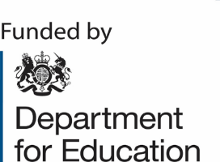

ENGLISH HUBS
St John Bosco National English Hub

DfE accredited programmes:

TSRC - Transforming your schools Reading Culture- Love of Reading
5 sessions 24th October, 5th December,6th February,9th April, 4th June
Early Language –FULL 23/24
6 sessions 11th Oct 23,29th Nov 23,7th Feb 24,20th Mar 24,22nd May 24,10th July 24.

THE ABOVE COURSES ARE CLOSED FOR 23/24.
If you would further information and would like to register your interest for 24/25 please complete https://forms.office.com/e/FBcAteKvcx

