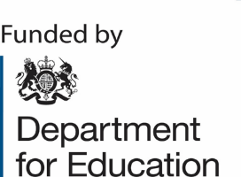ENGLISH HUBS

**St John Bosco National English Hub**

**Diane Pye** will be delivering the following two virtual sessions:

**Getting the Culture Right: 26th January 2024 9am-12 noon**

Key features of an ambitious, inclusive curriculum for all. Establishing good habits from the start in early reading and language.

A half-day online live session led by Diane Pye.

**Reading beyond Phonics: 22nd February 2024 9am-12 noon**

Where the phonics screening check sits.

• Supporting fluency and confidence.

• What meaningful practice looks like.

• From learning to read to reading to learn

A two-hour online live session led by Diane Pye

**If you are interested please contact** [**marie.powell@st-johnbosco.sandwell.sch.uk**](mailto:marie.powell@st-johnbosco.sandwell.sch.uk)**, as soon as the link is available for you to book, Marie will send it to you.**