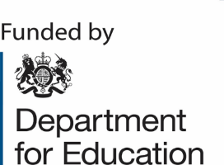

ENGLISH HUBS

**St John Bosco National English Hub**

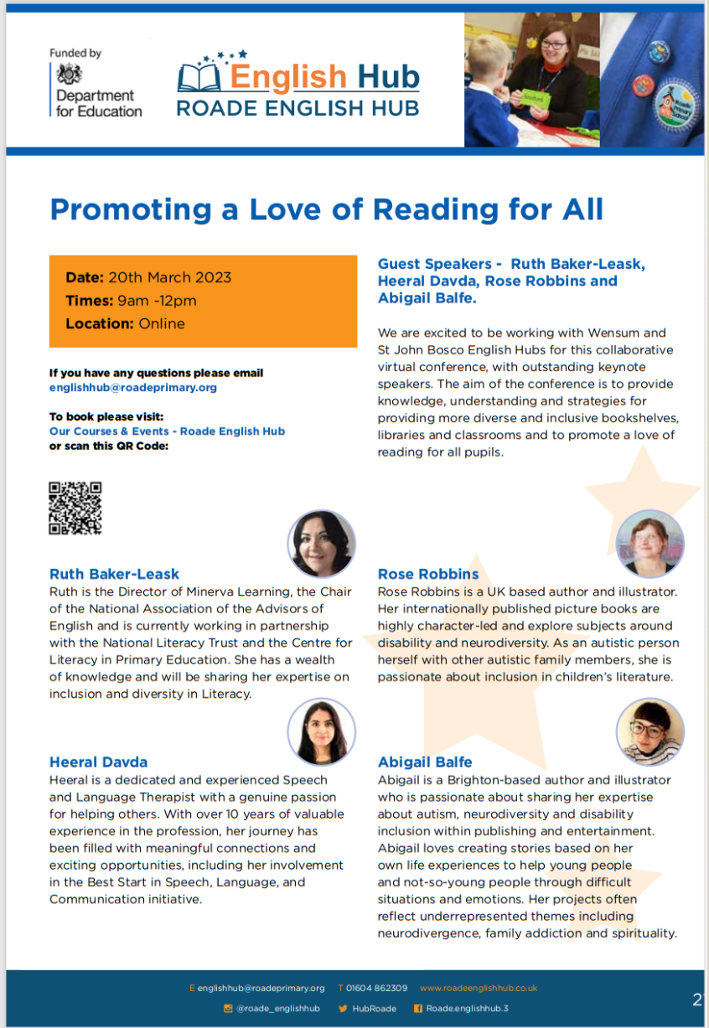

Date:20th March 2024

Time: 9am – 12pm

Location: Online

**Guest Speakers – Ruth Baker-Leask, Heeral Davda, Rose Robbins and Abigail Balfe.**

We are excited to be working with Wensum and Roade English Hubs for this collaborative virtual conference, with outstanding keynote speakers. The aim of the conference is to provide knowledge, understanding and strategies for providing more diverse and inclusive bookshelves, libraries and classrooms to promote a love of reading for all pupils.

**To reserve your places please send your name and email address to:**

[marie.powell@st-johnbosco.sandwell.sch.uk](mailto:marie.powell@st-johnbosco.sandwell.sch.uk)